**Professional Healthcare Mobile App on JAVA**

**A PROJECT REPORT**

***Submitted by***

**Rohan Ghosh (20BCS9671)**

**Jai Budhraja (20BCS5816)**

**Kirti (20BCS7083)**

**Mohammad Badruddin (20BCS5907)**

**Liza Sharma (20BCS5845)**

***in partial fulfillment for the award of the degree of***

**Bachelor of Engineering**

**IN**

Computer Science and Engineering



**Chandigarh University**

15th November 2022



**BONAFIDE CERTIFICATE**

Certified that this project report **“Professional Healthcare Mobile App on JAVA”** is the bonafide work of **“Rohan Ghosh, Jai Budhraja, Kirti, Mohammad Badruddin, Liza Sharma”** who carried out the project work under my/our supervision.

**SIGNATURE**

Dr. Sandeep S. Kang

**HEAD OF THE DEPARTMENT** **Department -** CSE

**SIGNATURE**

Kirat Kaur (E12999)

**SUPERVISOR**

Assistant Professor

**Department -** CSE

Submitted for the project viva-voce examination held on

INTERNAL EXAMINER EXTERNAL EXAMINER

**TABLE OF CONTENTS**

[CHAPTER 1. INTRODUCTION 6](#_Toc116470700)

[1.1. Client Identification/Need Identification/Identification of relevant Contemporary issue 6](#_Toc116470701)

[1.2. Identification of Problem 6](#_Toc116470702)

[1.3. Identification of Tasks- 6](#_Toc116470703)

[1.4. Timeline 7](#_Toc116470704)

[1.5. Organization of the Report 7](#_Toc116470705)

[CHAPTER 2. LITERATURE REVIEW/BACKGROUND STUDY 8](#_Toc116470706)

[2.1. Timeline of the reported problem 8](#_Toc116470707)

[2.2. Proposed solutions 8](#_Toc116470708)

[2.3. Bibliometric analysis 8](#_Toc116470709)

[2.4. Review Summary 9](#_Toc116470710)

[2.5. Problem Definition 9](#_Toc116470711)

[2.6. Goals/Objectives 10](#_Toc116470712)

[CHAPTER 3. DESIGN FLOW/PROCESS 11](#_Toc116470713)

[3.1. Evaluation & Selection of Specifications/Features 11](#_Toc116470714)

[3.2. Design Constraints 11](#_Toc116470715)

[3.3. Analysis and Feature finalization subject to constraints 11](#_Toc116470716)

[3.4. Design Flow 11](#_Toc116470717)

[3.5. Design selection 11](#_Toc116470718)

[3.6. Implementation plan/methodology 11](#_Toc116470719)

[CHAPTER 4. RESULTS ANALYSIS AND VALIDATION 12](#_Toc116470720)

[4.1. Implementation of solution 12](#_Toc116470721)

[CHAPTER 5. CONCLUSION AND FUTURE WORK 13](#_Toc116470722)

[5.1. Conclusion 13](#_Toc116470723)

[5.2. Future work 13](#_Toc116470724)

[REFERENCES 14](#_Toc116470725)

[APPENDIX Error! Bookmark not defined.](#_Toc116470726)

ABSTRACT

Healthcare mobile apps are becoming a reality for users interested in keeping their daily activities under control. Doctor G is an application based upon android development. It aims to provide faster and efficient way to have a proper health service in your hands. The application provides the user to have his/her own data of any disease data here means the reports, medicinal routine, precautions and a data of the nearest hospital and the availability doctors 24/7. Most unique part of the application is that the users get a daily update of the disease viral in air by providing the bets precaution, affected symptoms, and home remedies because prevention is better than cure.

In the last years, several researchers have investigated the effect of healthcare mobile apps on the life of their users as well as the positive/negative impact they have on the quality of life. In doing so, we define a manual process that enables the creation of an extended taxonomy of healthcare users' requests. The results of our study show that users of healthcare apps are more likely to request new features and support for other hardware than users of different types of apps. Moreover, they tend to be less critical of the defects of the application and better support developers when debugging.

# INTRODUCTION

## Client Identification/Need Identification/Identification of relevant Contemporary issue

Growing demand for mobile care is fueling a healthcare revolution. Convenience features included in the health app allow users to easily record their health data and access treatment. This eliminates the need to see a doctor directly.

Healthcare app may vary in functionality, but its purpose remains the same. The benefits of mobile health apps make life easier for patients and doctors and support hospital management.

## Identification of Problem

The major problem in healthcare application is sometimes doctor can not provide the service instantly so the user has to wait for a while. There can be a condition when doctor is in Operation Theatre or dealing any client with critical condition.

During the cab service cabs driver may delay due to traffic or accidental prone conditions.

## Identification of Tasks-

The task of this project is to build a model in which user book slots under emergency conditions will be given priority services from the hospital as well as the partnered ride services. Medicine refilling or buying has been made easier and hassle free with our free home delivery medicine services by the partnered chemist.

## Timeline

Define the timeline (preferably using a Gantt chart).

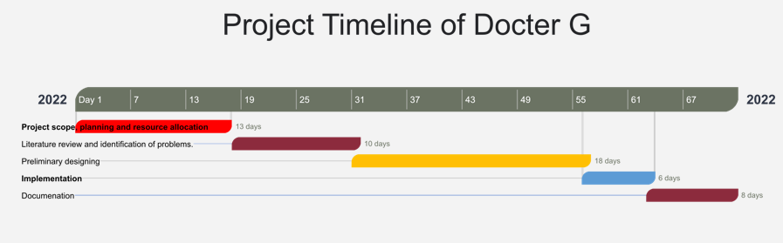

## Organization of the Report

The Healthcare industry has gained huge popularity among businesses and professionals in recent years, especially post-pandemic. Similarly, the market for mobile app development in healthcare is in its constantly evolving phase where every professional wants to experiment with healthcare and medical applications and software. The primary reasons for the escalating adoption and demand for healthcare app development are:

* Ease of healthcare access
* [Digital transformation in healthcare industry](https://appinventiv.com/blog/digital-transformation-in-healthcare/)
* Higher access to healthcare users online
* Better health tracking and monitoring through medical apps

# LITERATURE REVIEW/BACKGROUND STUDY

## Timeline of the reported problem

A lot of research has been done on health care applications in the past. Many methods and models have been proposed to enable the computer to generate these types of applications. Many of these approaches and models can be used in combination to create more effective and efficient models. The rough timeline of the models previously proposed is mentioned in the section below.

## Proposed solutions-

## The application is proposed in such a way that the client gets reached to the nearest medical center with the quickest availability of doctor of the specific department as needed by the patient. And the quickest possible cab service irrespective of the service providing company will be made available to the patient. Moreover, the cab driver will be rewarded a bonus of 10% of the base fare, if the cab driver reaches the destination within 7 mins, thus encouraging faster service and preventing patient’s health risk.

## Bibliometric analysis

## Bibliometrics is the quantitative study of literature and a measurable method used to identify the developmental trends within a certain field to obtain quantifiable, reproducible, and objective data. In this analysis, we computed the growth rate of publications, characteristics of research activities (topics and keywords), publication patterns (countries and journals), and research hotspot tendencies (citation bursts and timeline map).

## Review Summary

Health professionals and patients use a variety of medical smartphone applications that have been developed. The adoption of these programs is particularly beneficial since it improves patient-doctor communication and raises the standard of care as a whole. The review of the literature on healthcare applications reveals that different aspects of healthcare are covered by the applications, including patient care and monitoring, weight loss and fitness, communication between doctors and nurses on inpatient wards, and the use of smartphones for medical research and education. Our suggested healthcare system is built on Web and Android apps to provide medical support for patients who reside in areas with limited mobility. It can save both the patient and the doctor a ton of money.

## Problem Definition

Consultations that take place in person are related to healthcare. The sufferers are forced by this issue to rush to the closest medical facility for treatment.

Lockdowns and the COVID outbreak made it worse. People were contained within the four walls of their dwellings by the virus's contagious impact. So, what do they do if they have an emergency and need to visit a doctor? To keep ahead in the fight for technological adoption, the requirement for remote access or virtual consultations is urgent and must be addressed.

Despite notable improvements in medical research, the management technology used in the healthcare sector has led to ongoing inefficiencies and healthcare blunders.

This is more than just a barrier for medical research; because of the waste it produces, it slows progress. Patients not only pay the price for these inefficiencies and errors in terms of inconvenience and health, but we also see an increase in administrative costs and lawsuits as a result.

The interchange of patient data when a patient is transferred from one department or hospital to another is one particular area of concern. The usual method of transmitting patient records is time-consuming, ineffective, and leaves patients' data vulnerable to a breach.

## Goals/Objectives

One of the primary reasons why the healthcare mobile app development process became so popular is that it fulfills the needs of patients and doctors. Custom mobile app development for healthcare offers countless benefits to general users and business professionals while facilitating the progress of the healthcare industry. Let’s take a look at mobile healthcare software development benefits separately for different users.

Users who are interested in managing their everyday activities can now download healthcare mobile apps. An android-based application called Doctor G exists. It attempts to offer a more rapid and effective method of getting a good health service in your hands. The application enables the user to access personal information on any ailment, including reports, medication regimens, safety measures, information about the closest hospital, and information about the availability of doctors around-the-clock. The application's most distinctive feature is that users receive a daily update on any airborne diseases, along with the best preventative measures, symptoms to watch out for, and home cures.

Several scholars have looked into the impact of healthcare mobile in recent years.

# DESIGN FLOW/PROCESS

## Evaluation & Selection of Specifications/Features

This is why, we need a healthcare app development guide that talks about:

* Various healthcare and medical apps
* Types of healthcare mobile app development
* Business benefits of mobile healthcare application development
* mobile healthcare app development process
* Healthcare app development cost
* Why healthcare apps fail
* And how your business can develop healthcare mobile app solutions the right way

## Design Constraints

### Lack of detailed focus in any one domain

### Non-compliance with the law

### Lack of security

### Prevalent negative sentiment about the mobile health domain

### Presence of multiple channels and devices

## Analysis and Feature finalization subject to constraints

Despite the growing market size, many healthcare providers still think twice before launching a healthcare application in the market. Why? There are a number of [reasons why mobile healthcare solutions have not been able to create a ground breaking impact](https://appinventiv.com/blog/mhealth-development-features-and-challenges/) in the lives of medical stakeholders and bring a revolutionary global switch from traditional healthcare to mobile healthcare.

Understanding why healthcare businesses fail and why healthcare solutions are struggling to create a lasting impact in the lives of millions would help you devise your mobile app in a way that you become a nudge for those stakeholders who are on the fence measuring whether or not they should bring their medical life on mobile.

## Design Flow

At least 2 alternative designs/processes/flow to make the solution/complete the project.

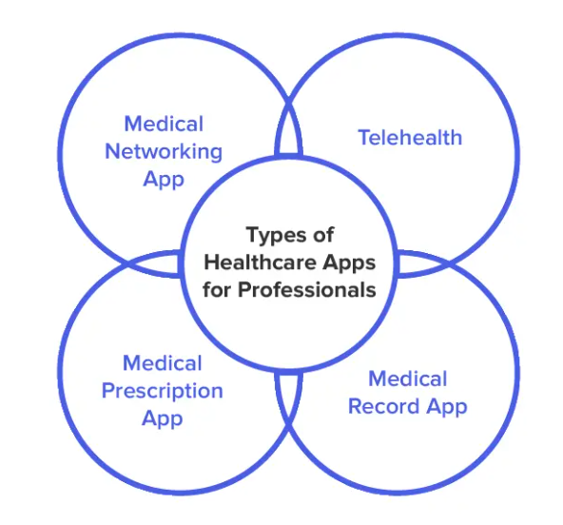

## Design selection

## Important factors to consider before developing a healthcare app

### Ensure that you are following all the compliance rules.

### Single-focused purpose

### Interoperability.

### Selection of feature set.

### Easy to flow UI and UX.

## Implementation plan/methodology

Flowchart/algorithm/ detailed block diagram

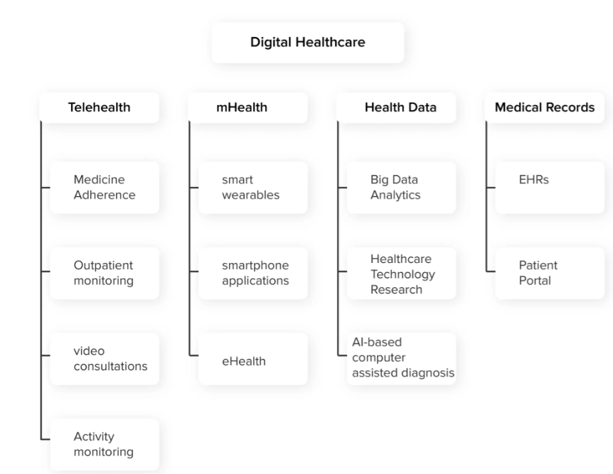

# RESULTS ANALYSIS AND VALIDATION

## Implementation of solution

Once the application has been tested, it’s time to welcome your users. After launching your app, make sure to track its performance using the [in-app analytics tools](https://appinventiv.com/blog/analytics-tool-right-app/) implemented during the development phase, address user concerns and requests, and introduce updates to keep users engaged.

While this was the general healthcare application development process, your healthcare app can stand out in the crowd through the concept and features it carries.

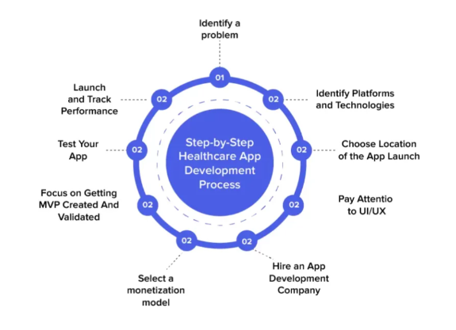

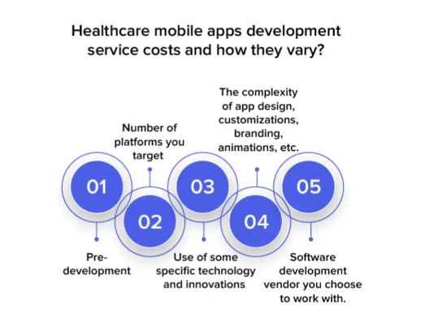

# CONCLUSION AND FUTURE WORK

## Conclusion

Although the popularity of mobile apps is growing and the interest of software engineers and medical scientists is notably high, only a few studies merge these two fields to bring evidence across domains. In this paper, we started looking at the intersection between mobile apps and healthcare mechanisms, by analyzing what the users of healthcare apps ask in their user reviews and whether they do that differently from non- healthcare users. To this purpose, we first manually analyzed 2,000 user reviews with the aim of classifying the types of comments left for healthcare and non-healthcare apps. Secondly, we assessed how the sentiment of these user reviews is and whether there are differences between healthcare and non-healthcare apps.

The main results of the study indicate the existence of ten categories of user reviews: while most of them are similar to those previously discovered in the literature, we found three additional ones. By analyzing them, we found that users of healthcare apps tend to ask more feature requests concerning other users, and this is likely because the developers of those apps are not aware of the specific customers' needs. Moreover, we found that healthcare users tend to be more proactive in the case of app's failures and try to propose solutions to developers.

## Future work

Our future research agenda is oriented to the definition and investigation of those novel methodologies. At the same time, we plan to corroborate the findings observed in this paper by analyzing more user reviews.

In addition, we plan to compare the development processes of those two categories through the analysis of the version control system guaranteed by the open access of the selected apps.

# REFERENCES

1. DeGusta M. Are smart phones spreading faster than any technology in human history. Massachusetts Institute of Technology Review, 2012. [[Google Scholar](https://scholar.google.com/scholar?q=DeGusta+M.+Are+smart+phones+spreading+faster+than+any+technology+in+human+history.+Massachusetts+Institute+of+Technology+Review,+2012.+)]

2. Smith A. Record shares of Americans now own smartphones, have home broadband. *Pew Research Center* 2017; 12:1-2. [[Google Scholar](https://scholar.google.com/scholar_lookup?journal=Pew+Research+Center&title=Record+shares+of+Americans+now+own+smartphones,+have+home+broadband.&author=A.+Smith&volume=12&publication_year=2017&pages=1-2&)]

3. Center PR. Mobile fact sheet. Pew Research Center: Internet, *Science & Tech*, 2017. [[Google Scholar](https://scholar.google.com/scholar_lookup?journal=Science+&+Tech&title=Mobile+fact+sheet.+Pew+Research+Center:+Internet&author=PR+Center&publication_year=2017&)]

4. Taylor K, Silver L. Smartphone Ownership is Growing Rapidly Around the World, but Not Always Equally. 2018. Available online: <https://www.pewresearch.org/global/2019/02/05/smartphone-ownership-is-growing-rapidly-around-the-world-but-not-always-equally/>

5. Lenhart A, Duggan M, Perrin A, et al. Teens, social media & technology overview 2015. Pew Research Center: Internet & American Life Project, 2015.

6. Twenge JM, Martin GN, Campbell WK. Decreases in psychological well-being among American adolescents after 2012 and links to screen time during the rise of smartphone technology. *Emotion* 2018; 18:765-80. 10.1037/emo0000403 [[PubMed](https://pubmed.ncbi.nlm.nih.gov/29355336)] [[CrossRef](https://doi.org/10.1037%2Femo0000403" \t "_blank)] [[Google Scholar](https://scholar.google.com/scholar_lookup?journal=Emotion&title=Decreases+in+psychological+well-being+among+American+adolescents+after+2012+and+links+to+screen+time+during+the+rise+of+smartphone+technology.&author=JM+Twenge&author=GN+Martin&author=WK+Campbell&volume=18&publication_year=2018&pages=765-80&pmid=29355336&doi=10.1037/emo0000403&)]

7. Twenge JM, Campbell WK. Associations between screen time and lower psychological well-being among children and adolescents: Evidence from a population-based study. *Prev Med Rep* 2018;12:271-83. 10.1016/j.pmedr.2018.10.003 [[PMC free article](https://www.ncbi.nlm.nih.gov/pmc/articles/PMC6214874/)] [[PubMed](https://pubmed.ncbi.nlm.nih.gov/30406005)] [[CrossRef](https://doi.org/10.1016%2Fj.pmedr.2018.10.003" \t "_blank)] [[Google Scholar](https://scholar.google.com/scholar_lookup?journal=Prev+Med+Rep&title=Associations+between+screen+time+and+lower+psychological+well-being+among+children+and+adolescents:+Evidence+from+a+population-based+study.&author=JM+Twenge&author=WK+Campbell&volume=12&publication_year=2018&pages=271-83&pmid=30406005&doi=10.1016/j.pmedr.2018.10.003&)]

8. Peracchia S, Curcio G. Exposure to video games: effects on sleep and on post-sleep cognitive abilities. A systematic review of experimental evidences. *Sleep Sci* 2018;11:302-14. 10.5935/1984-0063.20180046 [[PMC free article](https://www.ncbi.nlm.nih.gov/pmc/articles/PMC6361300/)] [[PubMed](https://pubmed.ncbi.nlm.nih.gov/30746049)] [[CrossRef](https://doi.org/10.5935%2F1984-0063.20180046" \t "_blank)] [[Google Scholar](https://scholar.google.com/scholar_lookup?journal=Sleep+Sci&title=Exposure+to+video+games:+effects+on+sleep+and+on+post-sleep+cognitive+abilities.+A+sistematic+review+of+experimental+evidences.&author=S+Peracchia&author=G+Curcio&volume=11&publication_year=2018&pages=302-14&pmid=30746049&doi=10.5935/1984-0063.20180046&)]

9. Tofighi B, Abrantes A, Stein MD. The Role of Technology-Based Interventions for Substance Use Disorders in Primary Care: A Review of the Literature. *Med Clin North Am* 2018;102:715-31. 10.1016/j.mcna.2018.02.011 [[PMC free article](https://www.ncbi.nlm.nih.gov/pmc/articles/PMC6563611/)] [[PubMed](https://pubmed.ncbi.nlm.nih.gov/29933825)] [[CrossRef](https://doi.org/10.1016%2Fj.mcna.2018.02.011" \t "_blank)] [[Google Scholar](https://scholar.google.com/scholar_lookup?journal=Med+Clin+North+Am&title=The+Role+of+Technology-Based+Interventions+for+Substance+Use+Disorders+in+Primary+Care:+A+Review+of+the+Literature.&author=B+Tofighi&author=A+Abrantes&author=MD+Stein&volume=102&publication_year=2018&pages=715-31&pmid=29933825&doi=10.1016/j.mcna.2018.02.011&)]

10. Moman RN, Dvorkin J, Pollard EM, et al. A Systematic Review and Meta-analysis of Unguided Electronic and Mobile Health Technologies for Chronic Pain-Is It Time to Start Prescribing Electronic Health Applications?. *Pain Med* 2019;20:2238-55. 10.1093/pm/pnz164 [[PubMed](https://pubmed.ncbi.nlm.nih.gov/31386151)] [[CrossRef](https://doi.org/10.1093%2Fpm%2Fpnz164" \t "_blank)] [[Google Scholar](https://scholar.google.com/scholar_lookup?journal=Pain+Med&title=A+Systematic+Review+and+Meta-analysis+of+Unguided+Electronic+and+Mobile+Health+Technologies+for+Chronic+Pain-Is+It+Time+to+Start+Prescribing+Electronic+Health+Applications?.&author=RN+Moman&author=J+Dvorkin&author=EM+Pollard&volume=20&publication_year=2019&pages=2238-55&pmid=31386151&doi=10.1093/pm/pnz164&)]

11. McCann L, McMillan KA, Pugh G. Digital Interventions to Support Adolescents and Young Adults With Cancer: Systematic Review. *JMIR Cancer* 2019;5:e12071. 10.2196/12071 [[PMC free article](https://www.ncbi.nlm.nih.gov/pmc/articles/PMC6693302/)] [[PubMed](https://pubmed.ncbi.nlm.nih.gov/31368438)] [[CrossRef](https://doi.org/10.2196%2F12071" \t "_blank)] [[Google Scholar](https://scholar.google.com/scholar_lookup?journal=JMIR+Cancer&title=Digital+Interventions+to+Support+Adolescents+and+Young+Adults+With+Cancer:+Systematic+Review.&author=L+McCann&author=KA+McMillan&author=G+Pugh&volume=5&publication_year=2019&pages=e12071&pmid=31368438&doi=10.2196/12071&)]

12. Naslund JA, Aschbrenner KA, Araya R, et al. Digital technology for treating and preventing mental disorders in low-income and middle-income countries: a narrative review of the literature. *Lancet Psychiatry* 2017;4:486-500. 10.1016/S2215-0366(17)30096-2 [[PMC free article](https://www.ncbi.nlm.nih.gov/pmc/articles/PMC5523650/)] [[PubMed](https://pubmed.ncbi.nlm.nih.gov/28433615)] [[CrossRef](https://doi.org/10.1016%2FS2215-0366(17)30096-2" \t "_blank)] [[Google Scholar](https://scholar.google.com/scholar_lookup?journal=Lancet+Psychiatry&title=Digital+technology+for+treating+and+preventing+mental+disorders+in+low-income+and+middle-income+countries:+a+narrative+review+of+the+literature.&author=JA+Naslund&author=KA+Aschbrenner&author=R+Araya&volume=4&publication_year=2017&pages=486-500&pmid=28433615&doi=10.1016/S2215-0366(17)30096-2&)]

13. Kaner EF, Beyer FR, Garnett C, et al. Personalized digital interventions for reducing hazardous and harmful alcohol consumption in community-dwelling populations. *Cochrane Database Syst Rev* 2017;9:CD011479. 10.1002/14651858.CD011479.pub2 [[PMC free article](https://www.ncbi.nlm.nih.gov/pmc/articles/PMC6483779/)] [[PubMed](https://pubmed.ncbi.nlm.nih.gov/28944453)] [[CrossRef](https://doi.org/10.1002%2F14651858.CD011479.pub2" \t "_blank)] [[Google Scholar](https://scholar.google.com/scholar_lookup?journal=Cochrane+Database+Syst+Rev&title=Personalised+digital+interventions+for+reducing+hazardous+and+harmful+alcohol+consumption+in+community-dwelling+populations.&author=EF+Kaner&author=FR+Beyer&author=C+Garnett&volume=9&publication_year=2017&pages=CD011479&pmid=28944453&doi=10.1002/14651858.CD011479.pub2&)]

14. Nesvåg S, McKay JR. Feasibility and Effects of Digital Interventions to Support People in Recovery From Substance Use Disorders: Systematic Review. *J Med Internet Res* 2018;20:e255. 10.2196/jmir.9873 [[PMC free article](https://www.ncbi.nlm.nih.gov/pmc/articles/PMC6127498/)] [[PubMed](https://pubmed.ncbi.nlm.nih.gov/30139724)] [[CrossRef](https://doi.org/10.2196%2Fjmir.9873" \t "_blank)] [[Google Scholar](https://scholar.google.com/scholar_lookup?journal=J+Med+Internet+Res&title=Feasibility+and+Effects+of+Digital+Interventions+to+Support+People+in+Recovery+From+Substance+Use+Disorders:+Systematic+Review.&author=S+Nesv%C3%A5g&author=JR+McKay&volume=20&publication_year=2018&pages=e255&pmid=30139724&doi=10.2196/jmir.9873&)]

15. Harari GM, Lane ND, Wang R, et al. Using Smartphones to Collect Behavioral Data in Psychological Science: Opportunities, Practical Considerations, and Challenges. *Perspex Psychol Sci* 2016;11:838-54. 10.1177/1745691616650285 [[PMC free article](https://www.ncbi.nlm.nih.gov/pmc/articles/PMC5572675/)] [[PubMed](https://pubmed.ncbi.nlm.nih.gov/27899727)] [[CrossRef](https://doi.org/10.1177%2F1745691616650285" \t "_blank)] [[Google Scholar](https://scholar.google.com/scholar_lookup?journal=Perspect+Psychol+Sci&title=Using+Smartphones+to+Collect+Behavioral+Data+in+Psychological+Science:+Opportunities,+Practical+Considerations,+and+Challenges.&author=GM+Harari&author=ND+Lane&author=R+Wang&volume=11&publication_year=2016&pages=838-54&pmid=27899727&doi=10.1177/1745691616650285&)]

16. Buller DB, Berwick M, Lantz K, et al. Smartphone mobile application delivering personalized, real-time sun protection advice: a randomized clinical trial. *JAMA Dermatol* 2015;151:497-504. 10.1001/jamadermatol.2014.3889 [[PMC free article](https://www.ncbi.nlm.nih.gov/pmc/articles/PMC4431912/)] [[PubMed](https://pubmed.ncbi.nlm.nih.gov/25629710)] [[CrossRef](https://doi.org/10.1001%2Fjamadermatol.2014.3889" \t "_blank)] [[Google Scholar](https://scholar.google.com/scholar_lookup?journal=JAMA+Dermatol&title=Smartphone+mobile+application+delivering+personalized,+real-time+sun+protection+advice:+a+randomized+clinical+trial.&author=DB+Buller&author=M+Berwick&author=K+Lantz&volume=151&publication_year=2015&pages=497-504&pmid=25629710&doi=10.1001/jamadermatol.2014.3889&)]

17. Romeo A, Edney S, Plotnikoff R, et al. Can Smartphone Apps Increase Physical Activity? Systematic Review and Meta-Analysis. *J Med Internet Res* 2019;21:e12053. 10.2196/12053 [[PMC free article](https://www.ncbi.nlm.nih.gov/pmc/articles/PMC6444212/)] [[PubMed](https://pubmed.ncbi.nlm.nih.gov/30888321)] [[CrossRef](https://doi.org/10.2196%2F12053" \t "_blank)] [[Google Scholar](https://scholar.google.com/scholar_lookup?journal=J+Med+Internet+Res&title=Can+Smartphone+Apps+Increase+Physical+Activity?+Systematic+Review+and+Meta-Analysis.&author=A+Romeo&author=S+Edney&author=R+Plotnikoff&volume=21&publication_year=2019&pages=e12053&pmid=30888321&doi=10.2196/12053&)]

18. Ciman M, Wac K. Smartphones as Sleep Duration Sensors: Validation of the iSenseSleep Algorithm. *JMIR Mhealth Uhealth* 2019;7:e11930. 10.2196/11930 [[PMC free article](https://www.ncbi.nlm.nih.gov/pmc/articles/PMC6547769/)] [[PubMed](https://pubmed.ncbi.nlm.nih.gov/31115341)] [[CrossRef](https://doi.org/10.2196%2F11930" \t "_blank)] [[Google Scholar](https://scholar.google.com/scholar_lookup?journal=JMIR+Mhealth+Uhealth&title=Smartphones+as+Sleep+Duration+Sensors:+Validation+of+the+iSenseSleep+Algorithm.&author=M+Ciman&author=K.+Wac&volume=7&publication_year=2019&pages=e11930&pmid=31115341&doi=10.2196/11930&)]

19. LeGrand S, Muessig KE, McNulty T, et al. Epic Allies: Development of a Gaming App to Improve Antiretroviral Therapy Adherence Among Young HIV-Positive Men Who Have Sex With Men. *JMIR Serious Games* 2016;4:e6. 10.2196/games.5687 [[PMC free article](https://www.ncbi.nlm.nih.gov/pmc/articles/PMC4884268/)] [[PubMed](https://pubmed.ncbi.nlm.nih.gov/27178752)] [[CrossRef](https://doi.org/10.2196%2Fgames.5687" \t "_blank)] [[Google Scholar](https://scholar.google.com/scholar_lookup?journal=JMIR+Serious+Games&title=Epic+Allies:+Development+of+a+Gaming+App+to+Improve+Antiretroviral+Therapy+Adherence+Among+Young+HIV-Positive+Men+Who+Have+Sex+With+Men.&author=S+LeGrand&author=KE+Muessig&author=T+McNulty&volume=4&publication_year=2016&pages=e6&pmid=27178752&doi=10.2196/games.5687&)]

20. Henny KD, Wilkes AL, McDonald CM, et al. A rapid review of eHealth interventions addressing the continuum of HIV care (2007–2017). *AIDS and Behavior* 2018;22:43-63. 10.1007/s10461-017-1923-2 [[PMC free article](https://www.ncbi.nlm.nih.gov/pmc/articles/PMC5760442/)] [[PubMed](https://pubmed.ncbi.nlm.nih.gov/28983684)] [[CrossRef](https://doi.org/10.1007%2Fs10461-017-1923-2" \t "_blank)] [[Google Scholar](https://scholar.google.com/scholar_lookup?journal=AIDS+and+Behavior&title=A+rapid+review+of+eHealth+interventions+addressing+the+continuum+of+HIV+care+(2007%E2%80%932017).&author=KD+Henny&author=AL+Wilkes&author=CM+McDonald&volume=22&publication_year=2018&pages=43-63&pmid=28983684&doi=10.1007/s10461-017-1923-2&)]

21. Schoeppe S, Alley S, Rebar AL, et al. Apps to improve diet, physical activity and sedentary behaviour in children and adolescents: a review of quality, features and behaviour change techniques. *Int J Behav Nutr Phys Act* 2017;14:83. 10.1186/s12966-017-0538-3 [[PMC free article](https://www.ncbi.nlm.nih.gov/pmc/articles/PMC5483249/)] [[PubMed](https://pubmed.ncbi.nlm.nih.gov/28646889)] [[CrossRef](https://doi.org/10.1186%2Fs12966-017-0538-3" \t "_blank)] [[Google Scholar](https://scholar.google.com/scholar_lookup?journal=Int+J+Behav+Nutr+Phys+Act&title=Apps+to+improve+diet,+physical+activity+and+sedentary+behaviour+in+children+and+adolescents:+a+review+of+quality,+features+and+behaviour+change+techniques.&author=S+Schoeppe&author=S+Alley&author=AL+Rebar&volume=14&publication_year=2017&pages=83&pmid=28646889&doi=10.1186/s12966-017-0538-3&)]

22. Greer JA, Jacobs JM, Pensak N, et al. Randomized Trial of a Smartphone Mobile App to Improve Symptoms and Adherence to Oral Therapy for Cancer. *J Natl Compr Canc Netw* 2020;18:133-41. [[PubMed](https://pubmed.ncbi.nlm.nih.gov/32023526)] [[Google Scholar](https://scholar.google.com/scholar_lookup?journal=J+Natl+Compr+Canc+Netw&title=Randomized+Trial+of+a+Smartphone+Mobile+App+to+Improve+Symptoms+and+Adherence+to+Oral+Therapy+for+Cancer.&author=JA+Greer&author=JM+Jacobs&author=N+Pensak&volume=18&publication_year=2020&pages=133-41&pmid=32023526&)]

23. Thirumalai M, Rimmer JH, Johnson G, et al. TEAMS (Tele-Exercise and Multiple Sclerosis), a Tailored Telerehabilitation mHealth App: Participant-Centered Development and Usability Study. *JMIR Mhealth Uhealth* 2018;6:e10181. 10.2196/10181 [[PMC free article](https://www.ncbi.nlm.nih.gov/pmc/articles/PMC5992455/)] [[PubMed](https://pubmed.ncbi.nlm.nih.gov/29798832)] [[CrossRef](https://doi.org/10.2196%2F10181" \t "_blank)] [[Google Scholar](https://scholar.google.com/scholar_lookup?journal=JMIR+Mhealth+Uhealth&title=TEAMS+(Tele-Exercise+and+Multiple+Sclerosis),+a+Tailored+Telerehabilitation+mHealth+App:+Participant-Centered+Development+and+Usability+Study.&author=M+Thirumalai&author=JH+Rimmer&author=G+Johnson&volume=6&publication_year=2018&pages=e10181&pmid=29798832&doi=10.2196/10181&)]

24. Tate EB, Spruijt-Metz D, O'Reilly G, et al. mHealth approaches to child obesity prevention: successes, unique challenges, and next directions. *Transl Behav Med* 2013;3:406-15. 10.1007/s13142-013-0222-3 [[PMC free article](https://www.ncbi.nlm.nih.gov/pmc/articles/PMC3830013/)] [[PubMed](https://pubmed.ncbi.nlm.nih.gov/24294329)] [[CrossRef](https://doi.org/10.1007%2Fs13142-013-0222-3" \t "_blank)] [[Google Scholar](https://scholar.google.com/scholar_lookup?journal=Transl+Behav+Med&title=mHealth+approaches+to+child+obesity+prevention:+successes,+unique+challenges,+and+next+directions.&author=EB+Tate&author=D+Spruijt-Metz&author=G+O%27Reilly&volume=3&publication_year=2013&pages=406-15&pmid=24294329&doi=10.1007/s13142-013-0222-3&)]

25. Villanti AC, Johnson AL, Ilakkuvan V, et al. Social Media Use and Access to Digital Technology in US Young Adults in 2016. *J Med Internet Res* 2017;19:e196. 10.2196/jmir.7303 [[PMC free article](https://www.ncbi.nlm.nih.gov/pmc/articles/PMC5480010/)] [[PubMed](https://pubmed.ncbi.nlm.nih.gov/28592394)] [[CrossRef](https://doi.org/10.2196%2Fjmir.7303" \t "_blank)] [[Google Scholar](https://scholar.google.com/scholar_lookup?journal=J+Med+Internet+Res&title=Social+Media+Use+and+Access+to+Digital+Technology+in+US+Young+Adults+in+2016.&author=AC+Villanti&author=AL+Johnson&author=V+Ilakkuvan&volume=19&publication_year=2017&pages=e196&pmid=28592394&doi=10.2196/jmir.7303&)]

26. Laing SS, Alsayid M, Ocampo C, et al. Mobile Health Technology Knowledge and Practices Among Patients of Safety-Net Health Systems in Washington State and Washington, DC. *J Patient Cent Res Rev* 2018;5:204-17. 10.17294/2330-0698.1622 [[PMC free article](https://www.ncbi.nlm.nih.gov/pmc/articles/PMC6664329/)] [[PubMed](https://pubmed.ncbi.nlm.nih.gov/31414005)] [[CrossRef](https://doi.org/10.17294%2F2330-0698.1622" \t "_blank)] [[Google Scholar](https://scholar.google.com/scholar_lookup?journal=J+Patient+Cent+Res+Rev&title=Mobile+Health+Technology+Knowledge+and+Practices+Among+Patients+of+Safety-Net+Health+Systems+in+Washington+State+and+Washington,+DC.&author=SS+Laing&author=M+Alsayid&author=C+Ocampo&volume=5&publication_year=2018&pages=204-17&pmid=31414005&doi=10.17294/2330-0698.1622&)]

27. Akinola M, Hebert LE, Hill BJ, et al. Development of a Mobile App on Contraceptive Options for Young African American and Latina Women. *Health Educ Behav* 2019;46:89-96. 10.1177/1090198118775476 [[PubMed](https://pubmed.ncbi.nlm.nih.gov/29896969)] [[CrossRef](https://doi.org/10.1177%2F1090198118775476" \t "_blank)] [[Google Scholar](https://scholar.google.com/scholar_lookup?journal=Health+Educ+Behav&title=Development+of+a+Mobile+App+on+Contraceptive+Options+for+Young+African+American+and+Latina+Women.&author=M+Akinola&author=LE+Hebert&author=BJ+Hill&volume=46&publication_year=2019&pages=89-96&pmid=29896969&doi=10.1177/1090198118775476&)]